  
  A Residential Academic Programme
  Scholarship Entrance Exam
OLIVENEET 2024
For students of Class-XII in 2024-2025
Name of Student: ___________________________________ Roll No.____________
Course Name: _____________________Invigilator Sign/Date __________________
Duration : 2 hrs. Max Marks: 320

General Instruction-

• This question paper consists of questions from Physics, Chemistry, Botany, Zoology
• Multiple choice questions with one correct answer Question No. 1 to 180.
• No marks will be allotted/deducted if a questions is left unattempt.
• Blank papers, calculators, tablets, mobile phones or any other electronic gadget in any form are not allowed to be used.
• Write your name & Application form in BOLD (BLUE/BLAK Ball Point Pen) in the space provided of this booklet.
• All the rough work is to be done in the blank space provided in the question paper.

Mark distribution of question is as follows-
Question no. | Subject | Maximum Marks
1 to 20 | Physics | 80
21 to 40 | Chemistry | 80
41 to 60 | Botany | 80
61 to 80 | Zoology | 80

Instruction for filling OMR Sheet-

• Darken the appropriate circle on the original by applying sufficient pressure with dark pencil.
• Do not tamper OMR Sheet
• Write your name, application from no and name of the examination centre with black/blue ball point pen in the space provide for the purpose. Do not write any of these details anywhere else.
• Darken the circle on OMR (Optical Mark Recognition) sheet only if you are sure of the answer.
• The correct way to darken the circle is
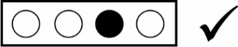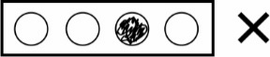
Subject: Physics

- Which of the following represents the relationship between the current flowing,I through the electric heater and the time taken, t.
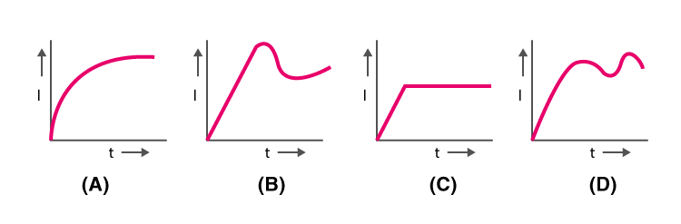
- Amass m is suspended from a weightless spring and it has time-period 'T'. The spring is now divided into four equal parts and the same mass is suspended from one of these parts. The now time period will be:-
(a)T (b)T/2 (c)2T (d)T/4
- A simple pendulum suspended from the roof of a lift oscillates with frequency υ when the lift is at rest. If the lift falls freely under gravity, its frequency of oscillation becomes :-
(a)zero (b) υ (c) 2u (d) infinite
- A thief is running away on a straight road in a jeep moving with a speed of 9 m/s. A police manchases him on a motor cycle moving at a speed of 10 m/s . If the instantaneous separation of thejeep from the motorcycle is 100m, how long will it take for the police man to catch the thief?
(a)1s (b) 19s (c) 90s (d) 100s
- Which of the following statement is true if a body moves in a semicircular track whose radius is R
(a) 2R is the displacement of the body (b) πR is the distance travelled by the body
(c) Both (a) and (b) are correct (d) None of the above
- The frequency of man's voice is 300 Hz and its wavelength is 1 meter. If the wavelength of a child's voice is 1.5m, then the frequency of the child's voice is :-
(a)200 Hz (b) 150 Hz (c) 400 Hz (d) 450 Hz
- A tuning fork of frequency 500 Hz is sounded on a resonance tube. The first and second resonance are obtained at 17 cm and 52 cm. The velocity of sound is :-
(a)170 m/sec (b) 350 m/sec (c) 520 m/sec (d) 850 m/sec
- A source is moving towards as observer with a speed of 20 m/s and having frequency of 240 Hz. The observer is moving towards the source with a velocity of 20 m/s. Apparent frequency heard by observer if velocity of sound is 340 m/s is :-
(a)270 Hz (b) 240 Hz (c) 268 Hz (d) 360 Hz
- 5 gm of steam at 100°C is passed into 6 gm of ice at 0°C. If the latent heats of steam and ice in cal per gm are 540 and 80 respectively, then the final temperature is :-
(a)0°C (b)100°C (c) 50°C (d) 30°C
- What is the need for laminating the core of a transformer?
(a) To reduce the resistance in the winding
(b) To reduce the eddy currents
(c) To reduce the hysteresis
(d) None of the above
- Two liquids A and B at 30°C and 20°C respectively. When equal mass of their is mixed final temperature is 26°C then ratio of their specific heat is
(a)4 : 3 (b) 3 : 4 (c) 2 : 3 (d) 3 : 2
- Temperature of a piece of iron is 27°C and it is radiating energy at the rate of Q kWm^{–2}. If its temperature is raised to 151°C, the rate of radiation of energy will become approximately:-
(a)2Q kWm² (b) 4Q kWm² (c) 6Q kWm² (d) 8Q kWm²
- Four tuning forks of frequencies 200,201, 204 and 206 Hz are sounded together. The beat frequency will be
(a)6 (b) 12 (c) 15 (d) None of these
- Which of the following represent the variation of induced EMF with respect to time t if a short bar magnet is moved along its axis and has a constant velocity.
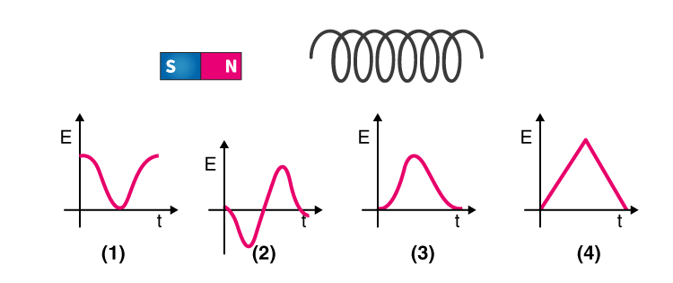
- A variable force (24t ² – 8t) Newton is acting on a particle. The impulse imparted to it in first two seconds will be :
(a)12 kg-m/s (b)24 kg-m/s (c)36 kg-m/s (d)48 kg-m/s
- A tuning fork gives 4 beats with 50 cm length of a sonometer wire. If the length of the wire is shortened by 1 cm, the number of beats is still the same. The frequency of the fork is :-
(a)404 Hz (b) 400 Hz (c) 396 Hz (d) 384 Hz
- What is the principle behind thermocouple
(a) Joule effect (b) Thomson effect (c) Seebeck effect (d) Peltier effect
- The thermodynamic variables of a jar filled with gas A are P, V and T and another jar B filled with another gas are 2P, V/4 and 2T, where the symbols have their usual meaning. The ratio of the number of molecules of jar A to those of jar B is :
(a)4 : 1 (b) 2 : 1 (c) 1 : 2 (d) 1 : 1
- The particle executing simple harmonic motion has a kinetic energy K_{o} cos²ωt. The maximum values of the potential energy and the total energy are respectively :-
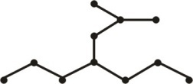
(a)K_{o} and K_{o} (b)0 and 2K_{o} (c)K/2and K_{o} (d)K_{o} and 2K_{o}
- A solid sphere and a hollow sphere of same material and size are heated to same temperature and allowed to cool in the same surroundings. If the temperature difference between each sphere and its surroundings is T, then:
(a)the hollow sphere will cool at a faster rate for all values of T.
(b)the solid sphere will cool at a faster rate for all values of T
(c)both spheres will cool at the same rate for all values of T
(d)both spheres will cool at the same rate only for small values of T.

SUBJECT : CHEMISTRY
- When chlorine is passed through propene at 500°C, which of the following is formed?
(a)PVC (b)Allyl chloride (c)Vinyl chloride (d)1, 2-Dichloropropane
- Theproduct of the following reaction is–
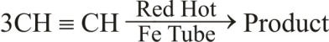
(a) 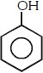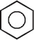
(b)
(c) 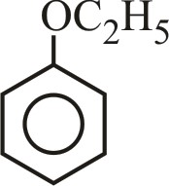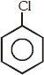
(d)
- The rate of diffusion of two gases x and y is 10 ml/s and 40 ml/s respectively then ratio of their molar masses is :-
(a)1 : 2 (b) 2 : 1 (c) 4 : 1 (d) 16 : 1
- Consider the following reaction,
3Br + 6CO₂⁻³+ 3H₂O 2 → 5Br⁻ + BrO₃⁻ + 6HCO₃⁻Which of the following statements is true regarding this reaction :-
(a)Bromine is oxidized and the carbonate is reduced
(b)Bromine is reduced and the carbonate is oxidized.
(c)Bromine is neither reduced nor oxidized.
(d)Bromine is both reduced and oxidized.

- Among the following, the intensive property is :-
(a)Mass (b) Volume (c) Surface tension (d) Enthalpy
- Oxidation of which of the following arenes does not give benzoic acid –
(a)Ethylbenzene (b)Cumene (c)Mesitylene (d)s-Butylbenzene
- When huge amount of sewage is dumped into a river, the BOD will –
(a)Increase (b)Remain unchanged
(c)Slightly decrease (d)Decrease
- Which chemical absorbs CO₂ gas in Duma's method :-
(a)KOH (b)H₂SO₄ (c)CH₃COOH (d)NH₂CONH₂
- Which technique is use to separate glycerol from spent lye in soap industry?
(a)Steam distillation (b)Reduced pressure distillation
(c)Crystallisation (d)Fractional distillation
- Which of the following has maximum heat of hydrogenation?
(a)1-butene (b) cis-2-butene (c) trans-2-butene (d) All have same
- Δ_{f}Uof formation of CH_{4(g)} at certain temperature is –393 kJ mol^{–1}. The value of Δ_{f}H is :-
(a)zero (b) <Δ_{f}U (c) >Δ_{f}H (d) equal to Δ_{f}U
- At a certain temperature the value of pK_{w} is13.4 and the measured pH of solution is 7. The solution is :-
(a)Acidic (b) Basic (c)Neutral (d) Unpredictable

- 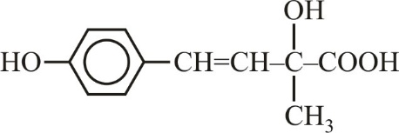will show :-
.
(a)Geometrical isomerism (b)Optical isomerism
(c)Both 1 and 2 (d)Neither G.I. nor O.I.
- The maximum value of dihedral angle in anti form of n-Butane is :-
(a)180° (b) 60° (c) 360° (d) 90°
- Which of the following compound is most acidic?
(a) 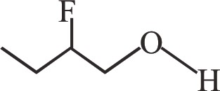 (b) 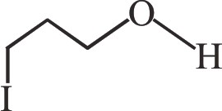

(c) 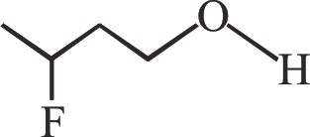 (d) 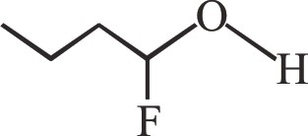

- Choose the correct statement ?
(a)Resonance is temporary effect.
(b)Resonance hybrid is hypothetical structure.
(c)Connonicalstructure are real in nature.
(d)Resonance hybrid is always more stable than cannonical structure's.

- Least reactive chloride towards S_{N}1 reaction is :-
(a) 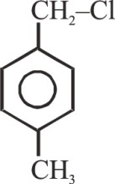 (b) 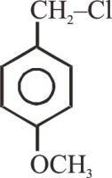
(c) 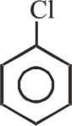 (d) 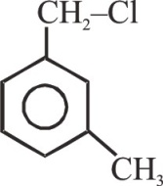
- If the molar concentration of CaCl₂ is 1.5 × 10^{–2}mol L^{–1} then the concentration of chloride ions in g molL^{–1} is :-
(a)3 × 10^{–2} (b) 1.5 × 10^{–2} (c) 7.5 × 10^{–3} (d) 6 × 10^{–2}
- Which of the following alkyl bromides is used for the synthesis of 2,3-dimethylbutane by wurtz reaction ?
(a)n-propyl bromide (b) isopropyl bromide
(c) isobutyl bromide (d) s-butyl bromide
- Which of the following has maximum –I effect :-
(a) (b) Cl⁻ (c) CN – (d)F⁻

Subject: Botany

41. In which one of the following processes, CO₂ is not released?
(a)Aerobic respiration in plants (b)Aerobic respiration in animals
(c)Alocholic fermentation (d)Lactate fermentation
42. Respiratory quotient (RQ) less than one indicates :-
(a)Carbohydrates are used as respiratory substrates
(b)Organic acids are used as respiratory substrates
(c)Oxidation of respiratory substrate consume more O₂ than CO₂ released
(d)Oxidation of respiratory substrate consume less O₂ than CO₂ released
43. Total yield in one Kerbs cycle:
(a)3 FADH₂, 2 NADH₂, 1 ATP (b)2 FADH₂, 2 NADH₂, 2 ATP
(c)2 NADH₂, 1 FADH₂, 2 ATP (d)3 NADH₂, 1 FADH₂, 1 ATP

44. Match the following columns :-
 | I
(A) | Glycolysis | (i) | Inner Mitochondrial membrane
(B) | TCA cycle | (ii) | Mitochondrial matrix
(C) | ETS | (iii) | Cytoplasm

-
(a) A - (iii), B - (i), C - (ii) (b) A - (iii), B - (ii), C - (i)
(c) A - (i), B - (ii), C - (iii) (d) A - (ii), B - (i), C - (iii)
45. Which of the following statements is wrong about imbibition ?
(a)It is a type of diffusion
(b)Affinity between adsorbent and liquid is not a pre-requisite
(c)It leads to increase in volume
(d)Seed germination is mediated by this process
46. Which of the following is correct?
(a)Water potential of a solution is always greater than that of pure water.
(b)Water potential of a solution is always zero at atmospheric pressure
(c)At atmospheric pressure water potential of pure water is zero but of solution is less than zero
(d)At atmospheric pressure water potential of a solution is always
47. Given below is the diagram of pathway of movement of water in the root. Which option is correct regarding labeling of A,B,C,D
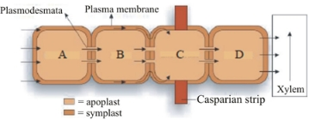
(a)Endodermis,cortex,pericycle epidermis (b)Endodermis, pericycle, epidermis, cortex
(c)Epidermis, endodermis,cortex, pericycle (d)Endodermis,cortex,epidermis, pericycle
48. Transpiration has all of the following purposes except one and that is :-
(a)Creation of transpiration pull (b)Supply of water for photosynthesis
(c)Cooling the leaf surface (d)Development of root pressure
49. Similarity between simple diffusion and facilitated diffusion is :-
(a)Both require specific proteins (b)Both needs ATP
(c)Both depend on living system (d) Both are down-hill processes
50. Free living anaerobic N₂ fixer is :-
(a)Beijerinckia (b)Rhodospirillum
(c)Rhizobium (d)Azotobacter
51. Nitrogen fixation process requires a high input of energy i.e. ________ and it is obtained from _____ of host cell.
Choose the correct option for blanks in above given statement :-
(a)8 ATP for each NH₃produced; Respiration.
(b)16 ATP for each NH₃ produced; photosynthesis.
(c)32 ATP for each NH₃ produced; photosynthesis
(d) 16 ATP for each NH₃ produced; Respiration
52. In given diagram select incorrect :-
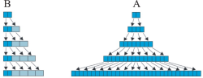
(a)A = Geometric growth (b) B = Arithmetic growth
(c)A = L_{t} = L₀ + rt (d)B = Growth at constant rate
53. Select incorrect pair :-
(a)Auxin – Hedge making (b)Environmental plasticity – Larkspur
(c)Gibberellic acid – increase in length of grapes stalk (d)Cells in culture – geometric growth
54. Plant hormone which speeds up the maturity period of conifers :-
(a)Auxin (b) Gibberellins (c) Ethylene (d) ABA
55. Gibberellins do not cause -
(a)Shortening of genetically tall plants (b)Stimulation of seed germination
(c)Promotion of malting process (d)Induction of α amylase synthesis in barley
56. The neural system provides or organised network of ___(B)___ connections for a ___(A)___ coordination. Choose the correct option for B & A to complete the given statement.
(a)A – point to point, B – chemical (b)A – chemical, B – fast
(c)A – Fast, B – point to point (d)A – Chemical, B – slow
57. Find out the correct match ?
(a) | Adrenaline | –Zonafasciculata layer of adrenal cortex
(b) | TCT | – Follicular cells of thyroid
(c) | ANF | – Atrial wall of heart
(d) | FSH | –Leydig cells of testes
58. Which of the following hormones are notsecreted by G.I.T cells :-
(a)Secretin (b)Renin (c)Cholecystokinin (d)Gastric inhibitory peptide
59. The current scientific definition of the hormone is:-
(a)Hormone is a chemical produced by endocrine glands and released into blood and transported to a
distantly located target organ.
(b)Hormones are non-nutrient chemicalswhich acts as intercellular messengers and are produced in
trace amounts.
(c)Hormones are non-nutrient chemicalswhich acts as intracellular messengers and are produced in
trace amounts
(d)Both (b) and (c)
60. Receptors for protein hormones are found :-
(a)Inside nucleus (b)Inside cytoplasm
(c)On surface of E.R (d)On cell surface

Subject: Zoology
61. The hypothalamic hormones reach the anterior pituitary gland through :
(a)Hypothalamic duct (b)Renal portal system
(c)Portal circulatory system (d)Hepatic portal circulation
62. Match the column-I with column-II :
(a) | Amoeboid movement | (i) | Trachea
(b) | Ciliary movement | (ii) | Tongue
(c) | Muscular movement | (iii) | Macrophage
(a) a-i, b-ii, c-iii (b) a-ii, b-i, c-iii (c) a-iii, b-i, c-ii (d) a-iii, b-ii, c-i
63. What is the correct sequence of event during contraction of muscle ?
(i) Neurotransmitter released (ii)Binding of myosin head with actin
(iii)Cross bridge formation (iv)Calcium released from sarcoplasmic reticulum
(v)Actin slides over myosin
(a) v, iv, i, iii, ii (b) i, iv, ii, iii, v (c) iii, v, i, iv, ii (d) ii, v, iii, i, iv
64. In which bone acromian process is found :-
(a)Pubis (b) Clavicle (c) Scapula (d) Humerus
65. Saddle joint present in between :-
(a)Metacarpals + Phalanges (b)Carpals + Metacarpals of thumb
(c)Radius + Carpal (d) Carpal + Carpal
66. Gout occurs due to accumulation of _____ in joints :
(a)Glucose crystals (b)Uric acid crystals
(c)Urea crystals (d)Acmmonia crystals
67. Which of the following refers to ‘cross arm’, in the myosin (thick) filament ?
(a)Light meromyosin (LMM)
(b)Head and short arm projecting outwards at regular distance and angle from each other
(c)Trimers of troponin
(d)Tropomyosin and troponin
68. Which of the following is autoimmune disorder leading to paralysis of skeletal muscle ?
(a)Myasthenia gravis (b)Tetanus (c)Tetany (d)Muscular dystrophy
69. Which More than one-half the volume of neural tissue in our body is made up of :-
(a)Neuron (b)Neuroglia (c)Ependyma (d) Neuro secretory cells.
70. In myelinated nerve fibres, the myelin sheath is present around the
(a)Cell body (b)Dendrites (c)Axons (d)Synaptic knobs
71. Association area in "cerebral cortex" are :
(a)Pure sensory areas
(b)Pure motor areas
(c)Responsible for intersensoryassociations memory and communication
(d)None of the above is correct
72. See the following diagram and identify A,B,C and D
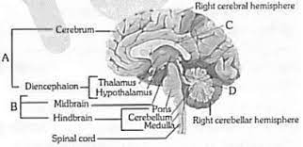
(a)A-Brainstem, B-Forebrain, C-Cerebral aqueduct, D-Corpus callosum
(b)A-Brainstem, B-forebrain, C- Corpus callosum, D-Cerebral aqueduct
(c)A-Forebrain, B-Brainstem, C-Cerebral aqueduct, D-Corpus callosum
(d)A-Forebrain, B-Brainstem, C-Corpus callosum, D-Cerebral aqueduct
73. See the figure
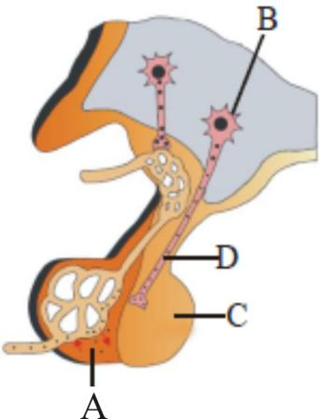
Which of the above is incorrect regarding part and function.
(a)A - Secretes proteinaceous hormone (b)B - Synthesis of prolactin hormone
(c)C - Stores pitocin& vasopressin (d)D - Transport of neurohormones
74. How many functions are related with pineal gland in the following ?
(i) Pigmentation (ii) Menstrual cycle
(iii) Sleep wake cycle (iv) Defense capability
(v) Metabolism (vi) Intelligent quotient
(a)Three (b) Four (c) Five (d) Six
75. Which of the following part of cytoskeleton help in amoeboid movement :
(a)Microtubules (b)Microfilaments (c)Intermediate filament (d) None of these
76. All of these statements about the mechanism of muscle contraction are given below.
  - Acetylcholine is released when the neural signal reaches the motor end plate.
  - Muscle contraction is initiated by a signal sent by CNS via a sensory neuron.
  - During muscle contraction isotropic bandgets elongated.
  - Repeated activation of the muscles can lead to lactic acid accumulation.
Identify the correct statement :
(a)I and IV are correct (b)I and III are correct
(c)II and III are correct (d)I and II are correct
77. Joint of skull bones are :-
(a)Fibrous joint (b)Cartilaginous joint
(c)Synovial joint (d)Gomphosis joint
78. Read the following statements (A to D):
(A) Rib is a thin flat bone connected ventrally to the vertebral column and dorsally to the sternum.
(B) First seven pairs of ribs are called true ribs.
(C) 8th, 9th& 10th pairs of ribs are called vertebro sternal ribs.
(D) Last two pairs of ribs are not connected dorsally and are therefore called floating ribs. How many statements are correct :
(a)One (b) Two (c)Three (d) None
79. Coronary angioplasty, part of CAD’s treatment involves:
(a) A new part of artery replaces the blocked section
(b) to expand artery, medication is used
(c) inflation of a tiny balloon inside an artery
(d) None of these
80. This is the classic ECG change in MI (myocardial infarction)
(a) ST-segment elevation (b) T-wave inversion
(c) Development of an abnormal Q wave (d) All of these

